10.82: Differentiating , and obtaining the answer to part (b),

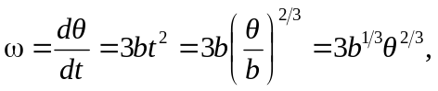
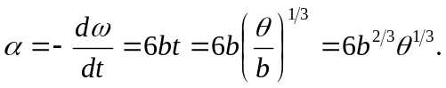

- a) 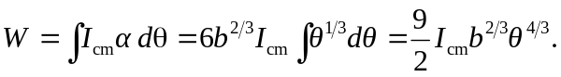
c) The kinetic energy is
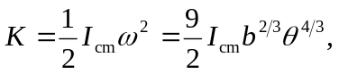
in agreement with Eq. (10.25); the total work done is the change in kinetic energy.

